PRESS RELEASE
COMMUNICATIONS AND MEDIA TEAM OF THE 43RD ASEAN SUMMIT 2023
No.25/SP/TKM-ASEAN2023/ENG/8/2023

Distinctive Indonesian Arabica Coffee to be Served at the 43rd ASEAN Summit
Jakarta, 1 September 2023 – The Gade Coffee and Gold, owned by PT Pegadaian, will brew three distinctive Indonesian Arabica coffees for delegates and journalists of the 43rd ASEAN Summit in Jakarta on 5 – 7 September 2023.
These Arabica coffee beans originate from Mount Ijen in Banyuwangi Regency of East Java, Bajawa Village in Ngada Regency of East Nusa Tenggara (NTT), and Boalemo Village in Central Aceh Regency of Aceh. These coffees are uniquely blended with a variety of flavors ranging from fruit, spices, to flowers.
“We have three high-quality Arabica coffees as our contribution to the ASEAN Summit,” said the Head of the Priority Services Department and The Gade Coffee and Gold of PT Pegadaian Taufan El Savir to the Communications and Media Team of the 43rd ASEAN Summit on Friday (1 September 2023).
Guests and journalists can enjoy these coffees at the locations of the 43rd ASEAN Summit and its Media Center. These coffee beans boast high quality because they were cultivated at an altitude of around 1,100 to 1,200 meters above sea level. According to Taufan, this factor also caused these three local Arabica coffees to have diverse flavors.
Based on his experience in brewing coffee at the State Palace, these beverages are often the first choice of President Joko Widodo and high-ranking officials to be served during discussions in both formal and informal events.
Coffee appears to be a powerful vitamin that keeps President Jokowi and his aides engaged in long discussions. A cup of coffee is often not enough for them. Sometimes, they drink more than two cups of coffee. “Mr. Prabowo once asked me to make coffee multiple times,” said Taufan.
This was also the case when he was entrusted with brewing coffee for the delegates of the 42nd ASEAN Summit in Labuan Bajo, West Manggarai, East Nusa Tenggara (NTT). At that time, many delegates ordered more than two cups of coffee at his booth located in front of the meeting room.
Taufan also received many compliments from members of the delegation who enjoyed his coffee. This boosted his confidence in his coffee blends which have a positive effect on many people.
“I received a lot of appreciation from the delegates who enjoyed my coffee,” said Taufan.
Taufan revealed the secret factor that makes his coffee blends popular among various segments of society, including President Joko Widodo. He mentioned that his Arabica coffee contains chemical compounds that provide taste, aroma, and physiological effects.
However, he also cautioned against excessive coffee consumption as it will adversely affect health. “A maximum of seven cups in one day. No more,” said Taufan. (Toro/Donna/TR/Elvira Inda Sari)
***
For more information, please contact:
Director General of Public Information and Communications of the Ministry of Communications and Informatics – Usman Kansong (0816785320).
Get more information at http://asean2023.id, https://infopublik.id/kategori/asean-2023, and https://indonesia.go.id/kategori/ragam-asean-2023

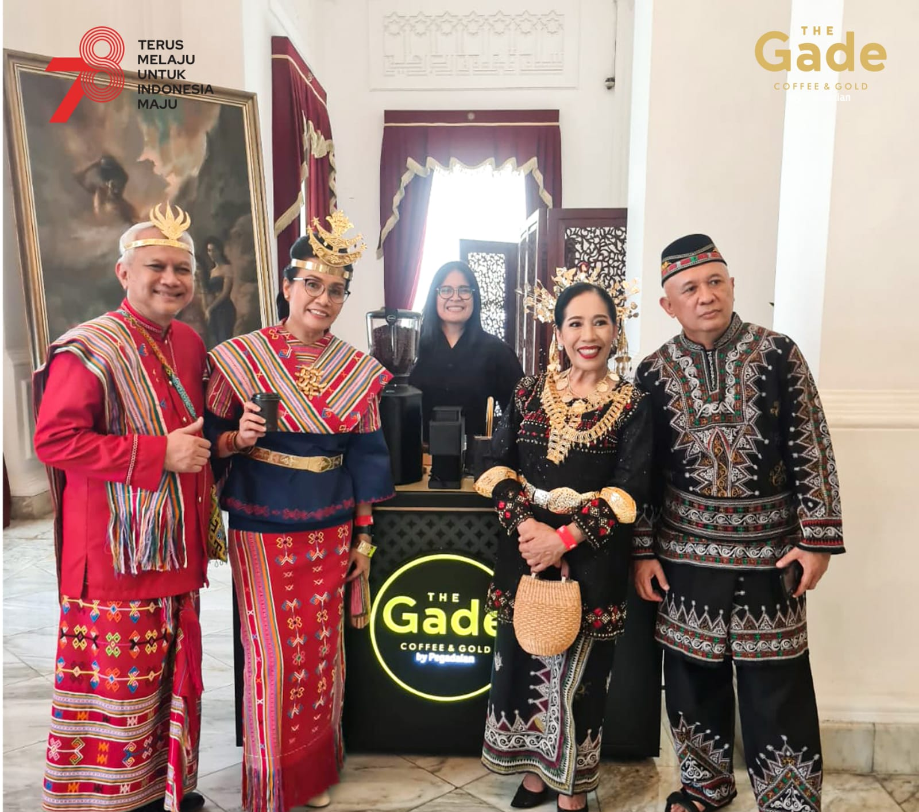
Minister of Finance Sri Mulyani (second left) and Minister of Cooperatives and Small and Medium Enterprises Teten Masduki (right) are fans of coffee made by The Gade Coffee and Gold. Photo: The Gade Coffee and Gold.

